APIs Diagram

1. Layers
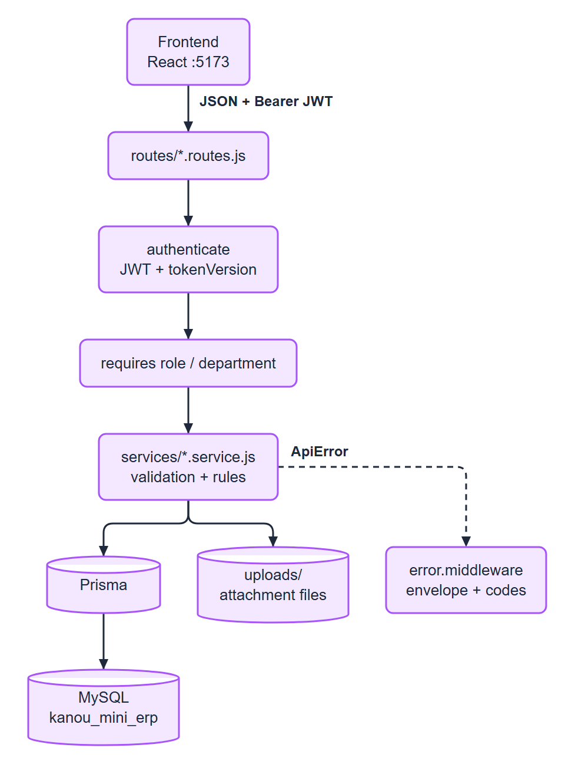
Figure 1. 1. Layers
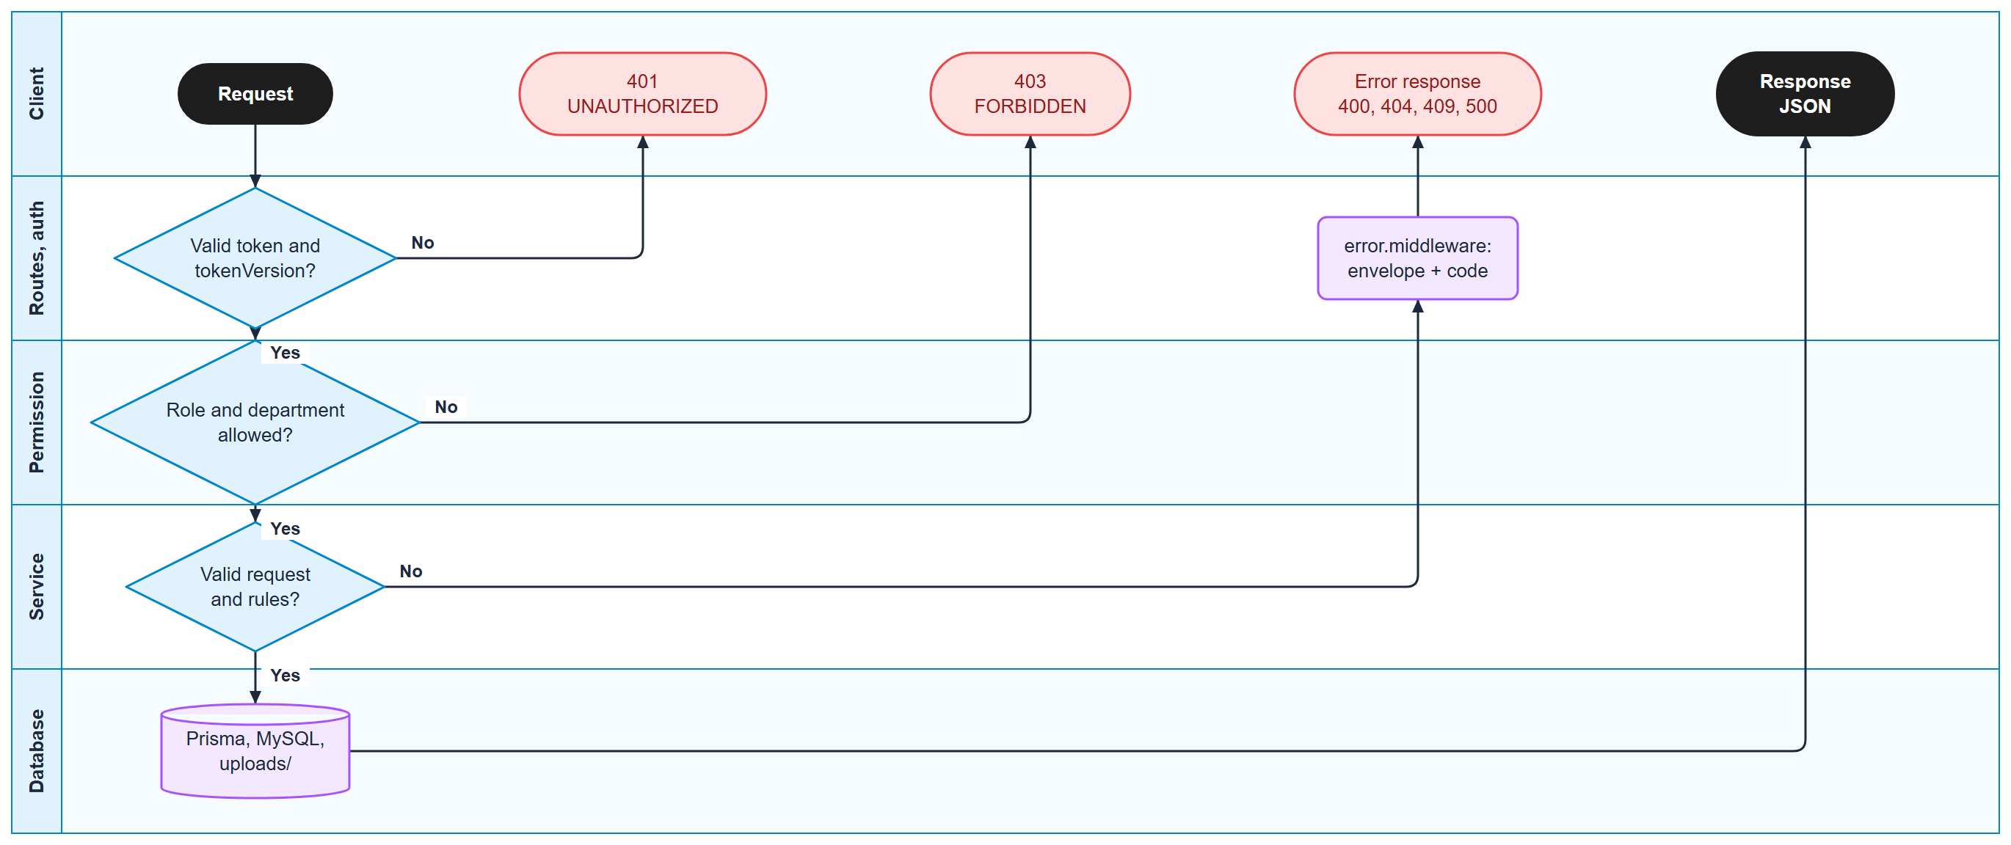
Figure 2. What every API call goes through (swimlanes)

2. Endpoints by module
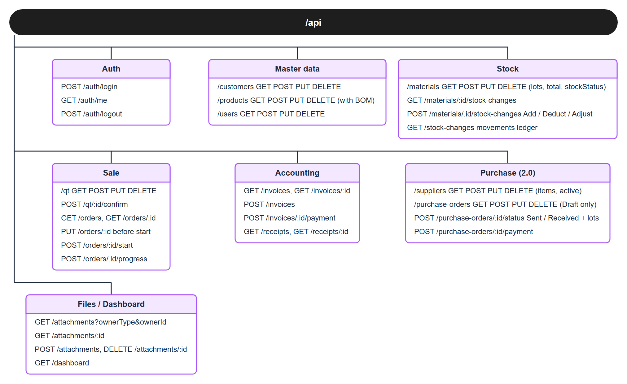
Figure 3. Endpoints by module
Query options added by the merged contract: GET /qt takes step (Draft, Confirmed, InProduction, Done) and every QT has a computed step; GET /orders takes invoiced (true / false); GET /suppliers takes materialId and active, and a list row has itemCount instead of items; a purchase order carries supplierAddress and its payment is { paymentDate, amount, method, referenceNo, note }.
List calls take q, page, pageSize and answer meta: { page, pageSize, total }. /orders, /qt, /invoices also take status; /materials takes status = Normal / Low / Out; /stock-changes takes type, from, to.

3. Who may call
Area | Admin | Sale Worker (Sales) | Factory Worker (Factory)
Dashboard, products read, materials read, stock history, orders read | yes | yes | yes
Customers read | yes | yes | 403
Customers, products, materials, users write | yes | 403 | 403
Users read | yes | 403 | 403
QT (all calls, Confirm, delete a Draft) | yes | yes | 403
PUT /orders/:id (before start) | yes | 403 | yes
POST /orders/:id/start, /progress | yes | 403 | yes
Stock change by hand | yes | 403 | yes
Reopen / change a Completed process | yes | 403 | 403
Suppliers read; purchase orders, payment, PO files | yes | 403 | yes
Suppliers write | yes | 403 | 403
Invoices, payments, receipts | yes | 403 | 403
Files of a QT (read, upload, delete) | yes | yes | 403
Files of an order: read | yes | yes | yes
Files of an order: upload, delete | yes | 403 | yes

The role check runs before the record lookup, so a forbidden user gets 403, not 404.

4. One sale, end to end
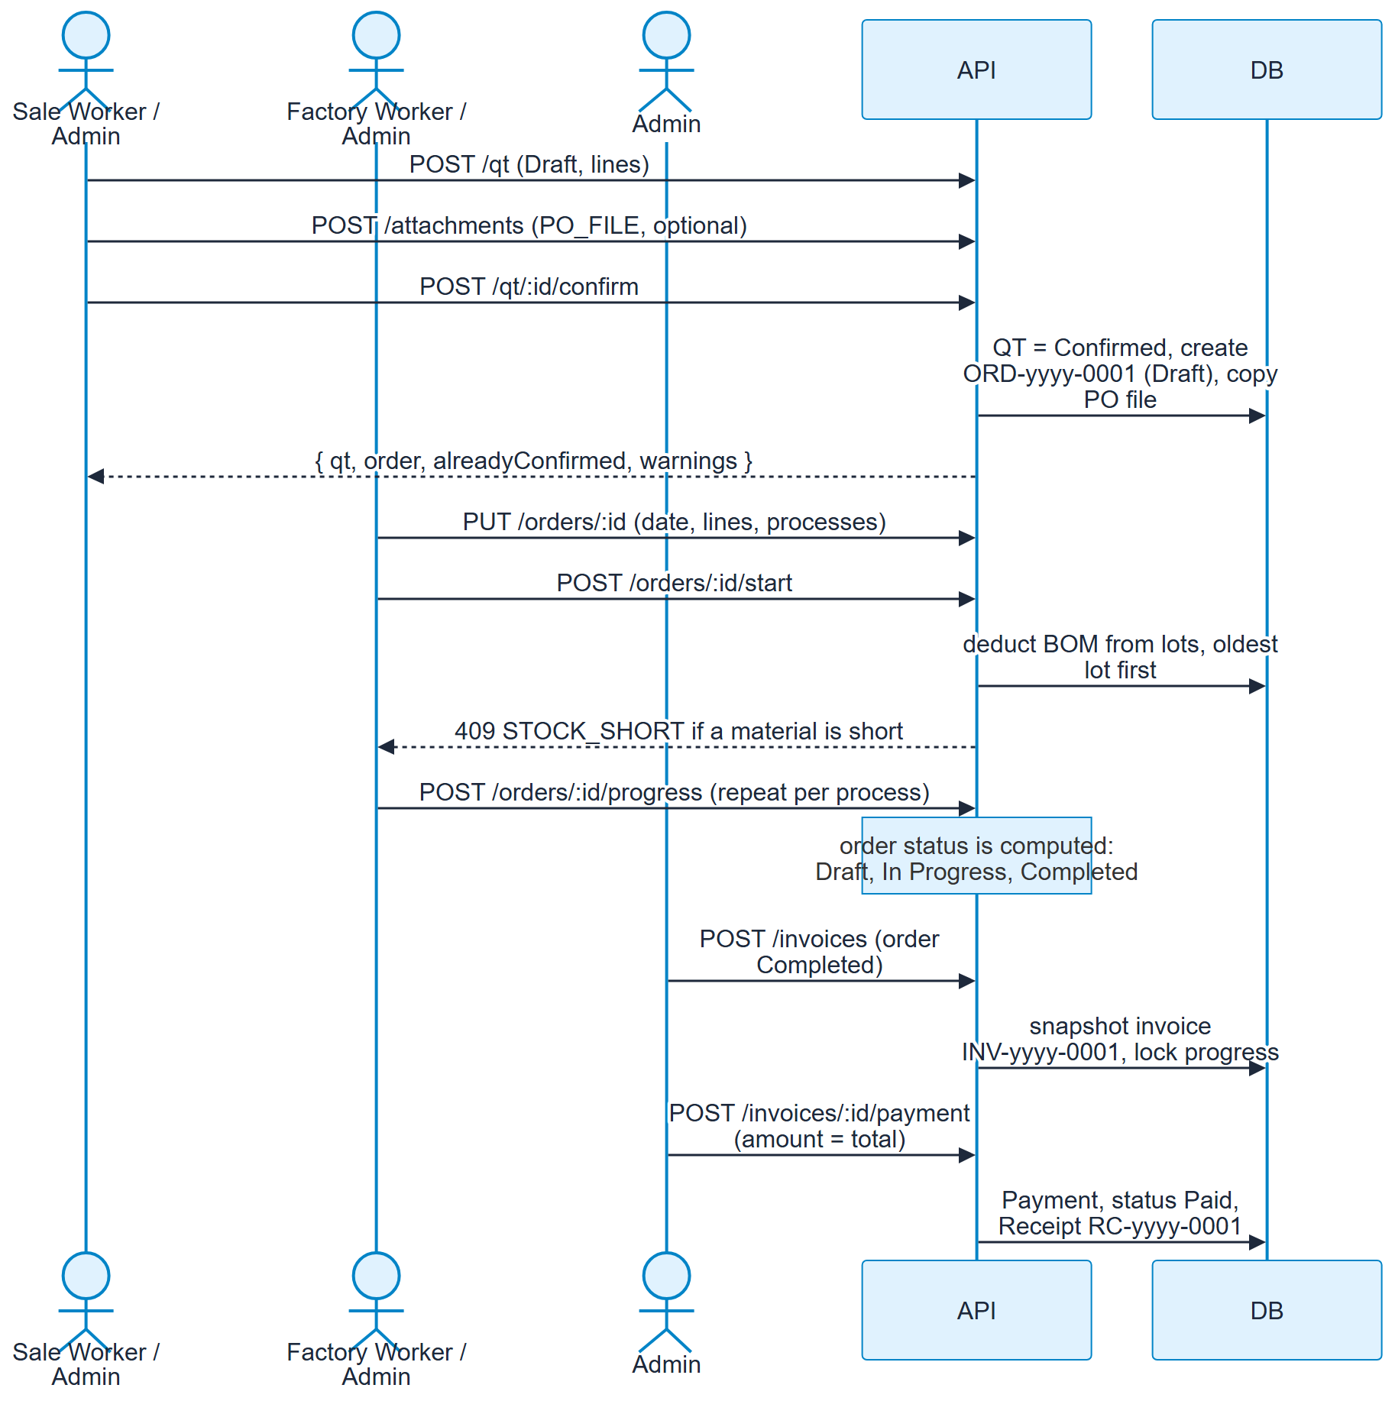
Figure 4. 4. One sale, end to end

Purchase flow
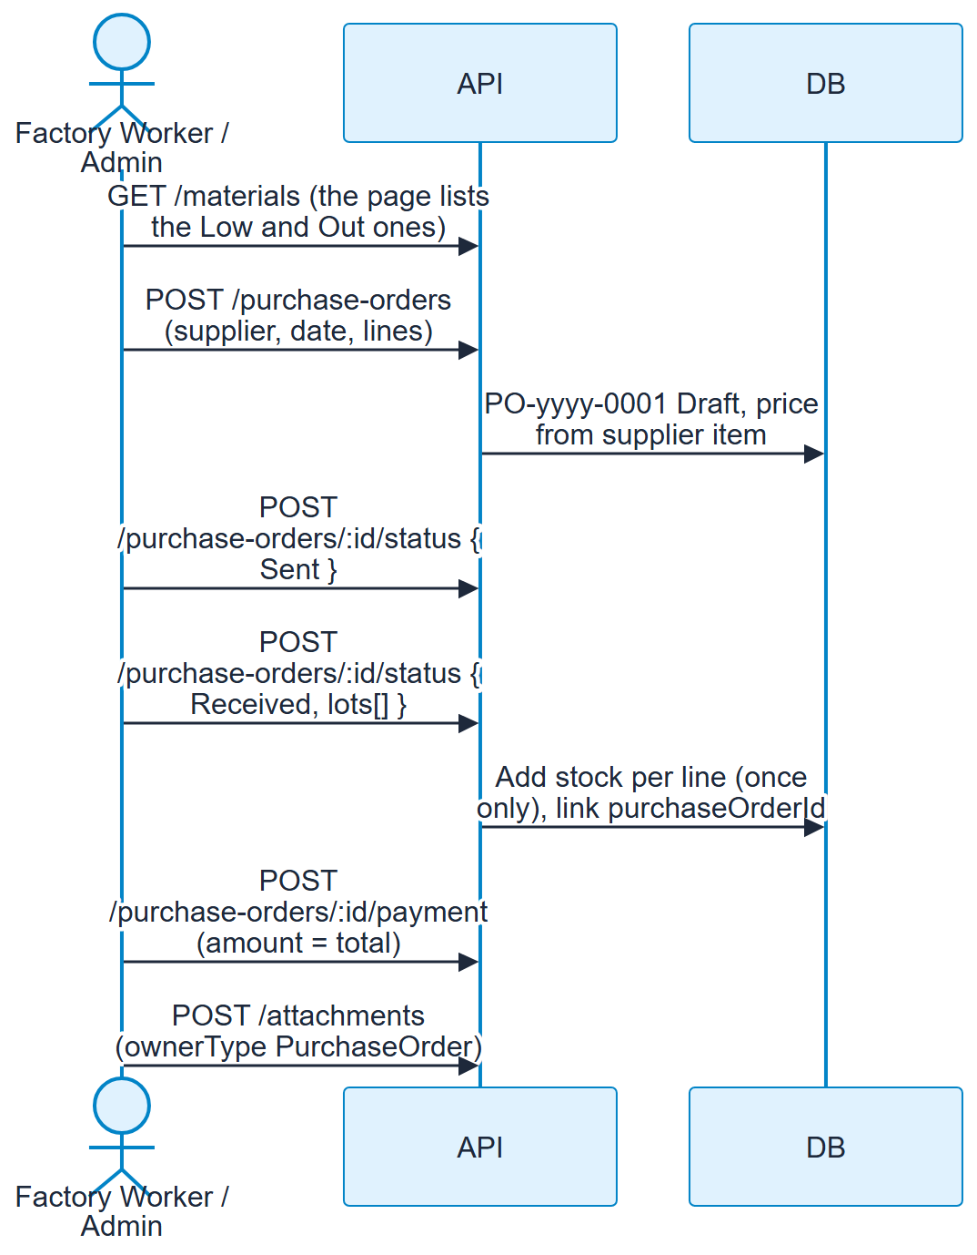
Figure 5. Purchase flow

5. Order and invoice states
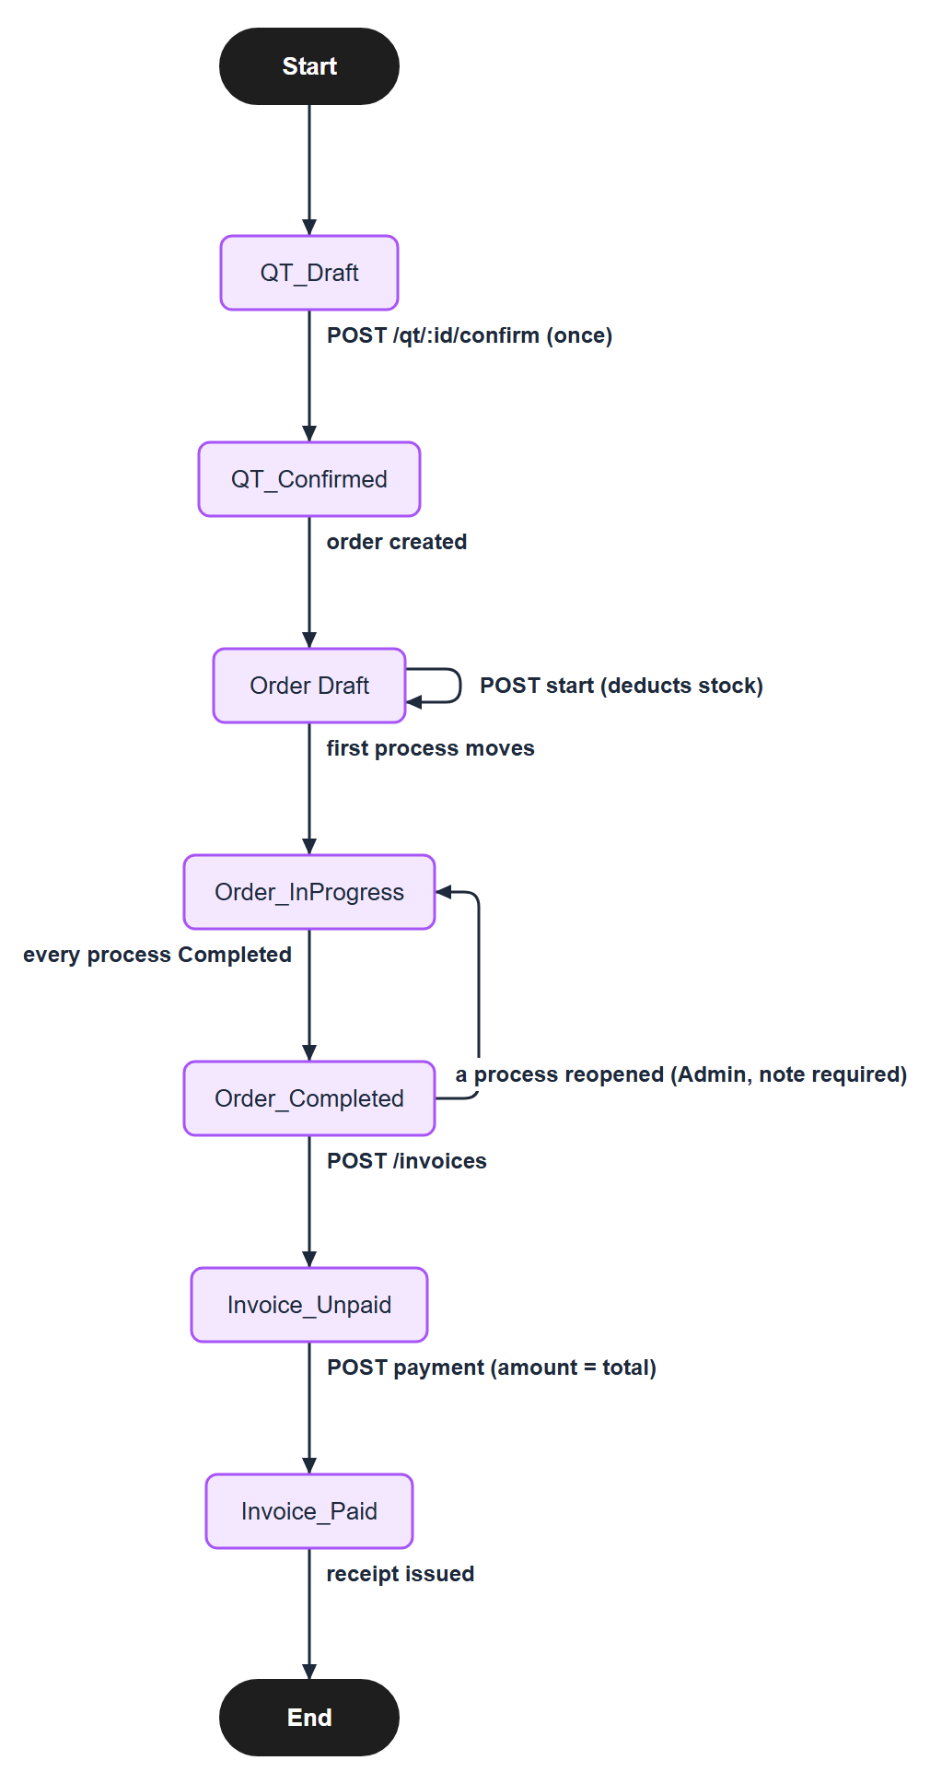
Figure 6. 5. Order and invoice states

6. Data model (tables)
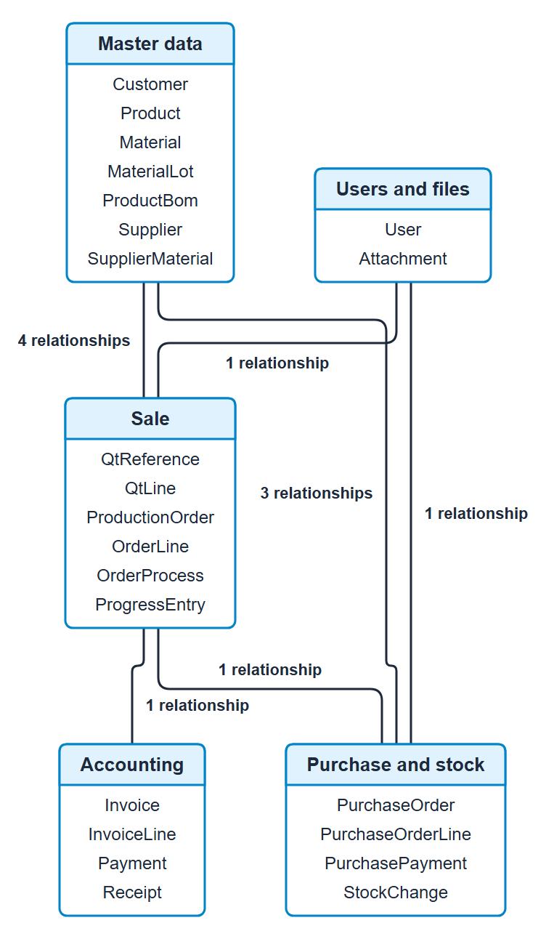
Figure 7. Data model: the 23 tables in 5 groups, and the relationships between the groups
Attachment points to its owner (QtReference or ProductionOrder) by ownerType + ownerId, with no database foreign key.

7. Error codes
HTTP | error | Typical cause
400 | VALIDATION_ERROR | errors: [{ path, code }], codes REQUIRED, INVALID, INVALID_DATE, DUPLICATE, TOO_SHORT, TOO_HIGH, MUST_EQUAL_TOTAL, FILE_TYPE, FILE_TOO_BIG ...
401 | UNAUTHORIZED, INVALID_CREDENTIALS | No / bad / old token; wrong login
403 | FORBIDDEN, COMPLETED_LOCKED | Role or department not allowed
404 | NOT_FOUND | No such record
409 | DUPLICATE_VALUE | Unique code, email, qtNumber used
409 | IN_USE | Delete of a used record; errors: [{ kind, count, items }]
409 | STOCK_SHORT, STOCK_NEGATIVE, LOT_NOT_FOUND | Stock rules
409 | QT_LOCKED, ORDER_LOCKED, ALREADY_STARTED, ORDER_NOT_READY, ORDER_NOT_STARTED, ORDER_INVOICED | Order / QT lifecycle
409 | PO_LOCKED, INVALID_STATUS_CHANGE, PO_NOT_RECEIVED | Purchase order lifecycle (ALREADY_PAID also covers a PO)
400 | SUPPLIER_INACTIVE, NOT_SOLD_BY_SUPPLIER (codes inside VALIDATION_ERROR) | Purchase order lines
409 | ORDER_NOT_COMPLETED, INVOICE_EXISTS, ALREADY_PAID, FILE_LOCKED | Accounting and files
429 | TOO_MANY_REQUESTS | Login rate limit
500 | INTERNAL_SERVER_ERROR | Unexpected failure

8. Tests
cd backend && pnpm test runs integration tests (Node test runner) that call the real Express app over HTTP against a separate database, kanou_mini_erp_test (made from DATABASE_URL with _test added; the tests refuse to run on any other name, because they empty every table). The schema is pushed by test-support/setup-db.js first.
File | Covers
test/auth.test.js | login, /me, logout, sessions ended by a new password, rate limit, 401 on every module
test/master.test.js | customers, products with BOM, users: validation, search, paging, roles, IN_USE, duplicates
test/stock.test.js | materials, lots, status, stock changes (Add / Deduct / Adjust), history, movements, delete rules
test/sale.test.js | QT, Confirm QT, files (PO copy to the order), production orders, start (stock deduction), progress rules
test/accounting.test.js | invoices (snapshot), payment, receipts, dashboard
test/purchase.test.js | suppliers, purchase orders, status path, receiving (stock once), payment, files, in-use rules

9. Status
All endpoints above are implemented in backend/src and covered by the tests. The development database kanou_mini_erp still has to be created with pnpm run db:setup (users admin@gmail.com / admin, worker@gmail.com / worker, sale@gmail.com / sale).

